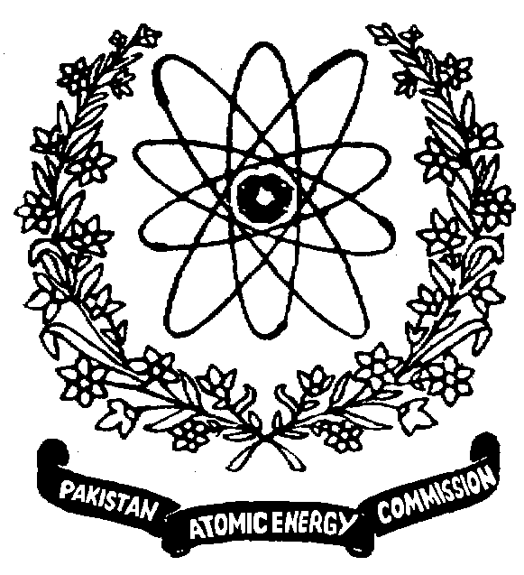 | Nuclear Institute for Food & Agriculture (NIFA)  P. O. Box 446, Tarnab, Peshawar, KP, Pakistan

Subject: APPROVAL OF RESEARCH SUPERVISOR
Student information
Name of Student: ______________________ Father name: _______________________________
Degree Program: _______________________ Registration No.: ____________________________
Session: ______________________________ Department: ________________________________
Name of University: ________________________________________________________________
Title of the proposed research area:____________________________________________________
_________________________________________________________________________________
Agreement for research work at NIFA, Peshawar:
NIFA and concerned university are agreed that (i) Co-supervisor will be responsible for ensuring the engagement of students in ongoing approved programs of NIFA (ii) Co-supervisor at NIFA shall be duly approved by ASRB/BASR/BOS of the university and notification shall be submitted within two months after approval from PAEC, HQs to co-supervisor and cc to manager ORIC (iii) Inclusion of co-supervisor name and prior written consent for publishing research work conducted at NIFA shall be obligatory (iv) The management of research work and the arrangement of chemicals, raw materials, human resource assistance or any other required items during the research will be the sole responsibility of the student (v) No financial assistance will be provided by NIFA

__________________________  Name and signature of student | ________________________ Name and signature of supervisor at University. Cell #:__________________ | __________________________  Name, Signature and seal of Chairman of Department

Co-supervisor information
Name of Co-Supervisor at NIFA: ________________________ PIN. No _______________________
□ Remuneration available. □ Remuneration not available.

The co-supervisor will be responsible for the relevancy of student’s research work with his own ongoing research. Moreover, he will ensure the submission of student’s thesis copy to NIFA Library.

Icharge Student Affairs: _______________________Sig. of Co-supervisor: _____________________ Sig. of HOD at NIFA: _________________________ Director NIFA: ______________________
Director General (Agric. & Biotech.): __________________________
Member Science: __________________________________________

